**Kale Chips**

**Ingredients:**

* 1 small bunch Kale
* Olive oil
* 1/8 tsp. garlic powder
* 1/8 tsp. salt

**Directions:**

1. Preheat oven to 375˚
2. Wash and **thoroughly** dry the kale using clean towels.
3. Using a rimmed cookie sheet, break kale into pieces and lay it across the cookie sheet.
4. Drizzle olive oil over the kale and toss the kale with your hands to coat.
5. Season the kale with garlic powder and salt.
6. Bake for 10.
7. Remove from oven, and flip kale leaves.
8. Bake another 10 minutes.
9. Enjoy!

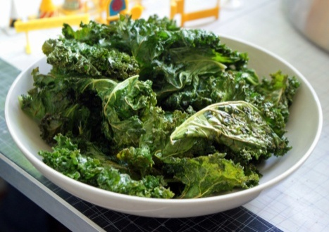

**HEALTH BENEFITS OF KALE**

1.**Kale is low in calories, high in fiber and has zero fat.** One cup of kale has only 36 calories, 5 grams of fiber and 0 grams of fat. It is great for aiding in digestion and elimination with its great fiber content. It’s also filled with so many nutrients, vitamins, folate and magnesium as well as those listed below.

**2. Kale is high in iron.**Per calorie, kale has more iron than beef. Iron is essential for good health, such as the formation of hemoglobin and enzymes, transporting oxygen to various parts of the body, cell growth, proper liver function and more.

**3. Kale is high in Vitamin K.** Eating a diet high in Vitamin K can help protect against various cancers. It is also necessary for a wide variety of bodily functions including normal bone health and the prevention of blood clotting. Also increased levels of vitamin K can help people suffering from Alzheimer’s disease.

**4. Kale is filled with powerful antioxidants.** Antioxidants, such as carotenoids and flavonoids help protect against various cancers.

**5. Kale is a great anti-inflammatory food.** One cup of kale is filled with 10% of the RDA of omega-3 fatty acids, which help, fight against arthritis, asthma and autoimmune disorders.

**6. Kale is great for cardiovascular support.**Eating more kale can help lower cholesterol levels.

**7. Kale is high in Vitamin A.**Vitamin A is great for your vision, your skin as well as helping to prevent lung and oral cavity cancers.

**8. Kale is high in Vitamin C.** This is very helpful for your immune system, your metabolism and your hydration.

**9. Kale is high in calcium.** Per calorie, kale has more calcium than milk, which aids in preventing bone loss, preventing osteoporosis and maintaining a healthy metabolism. Vitamin C is also helpful to maintain cartilage and joint flexibility

**10. Kale is a great detox food.** Kale is filled with fiber and sulfur, both great for[detoxifying](http://www.mindbodygreen.com/tag/detox.html) your body and keeping your liver healthy